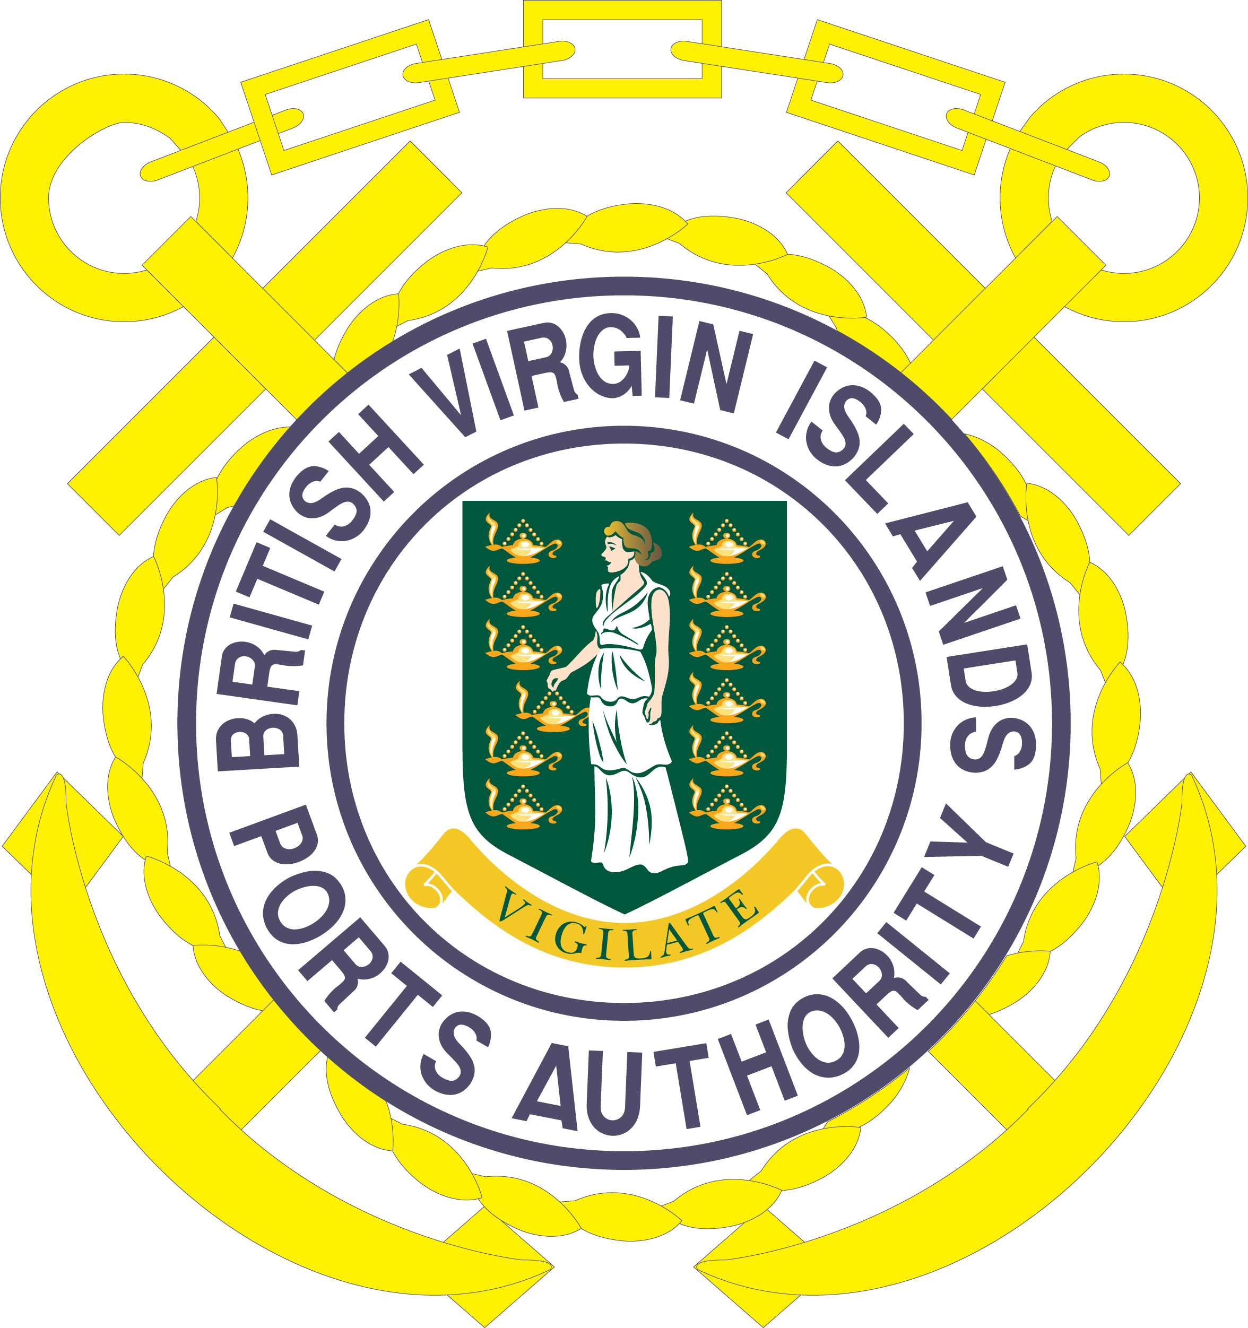
BRITISH VIRGIN ISLANDS PORTS AUTHORITY
VACANCY NOTICE 3/2020

The British Virgin Islands Ports Authority is seeking mature, and highly motivated persons to join our Team in the following position:
Public Relations Officer

Specific Accountabilities:

Guide the Authority’s communication to the public and to maintain a positive image. The Public Relations Officer will also be responsible for providing information to the public and media on all matters of public interest in a timely manner, on all Port related matters, as approved by the Deputy Managing Director.

- Serves as the chief communication advisor to the Port’s Authority.
- Prepares the Deputy Managing Director and Senior Officers (as directed by the Deputy Managing Director) for public events and manage their public reputation.
- Communicates Board decisions to the public, in consultation with the Deputy Managing Director.
- Manages outreach to shape public opinion on the role and work of the Authority.
- Liaises with the media; locally, regionally, internationally and answers media enquiries on behalf of the Authority, following consultation with the Deputy Managing Director.
- Coordinates implementation of the Authority’s communications strategy to ensure synchronised communications.
- Prepares and reviews media releases, newsletter articles and print media columns to ensure they are aligned with the Authority’s strategic communications direction and organisational agenda.

Person Specifications:

Minimum Acceptable Academic/Technical/Professional Qualifications

- Bachelor’s Degree in Journalism or Public Relations or a related field

Minimum Number of Years of Relevant Experience

- Three (3) years experience in a Public Relations post

Salary:

Remuneration/ Benefits: Based on qualifications and experience.

Closing Date: 05th June, 2020.

Please send applications to:

Deputy Managing Director
British Virgin Islands Ports Authority
Box 4, Road Town, Tortola.
British Virgin Islands
Or email to: omaynard@bviports.org
For further information, please visit our website at www.bviports.org

