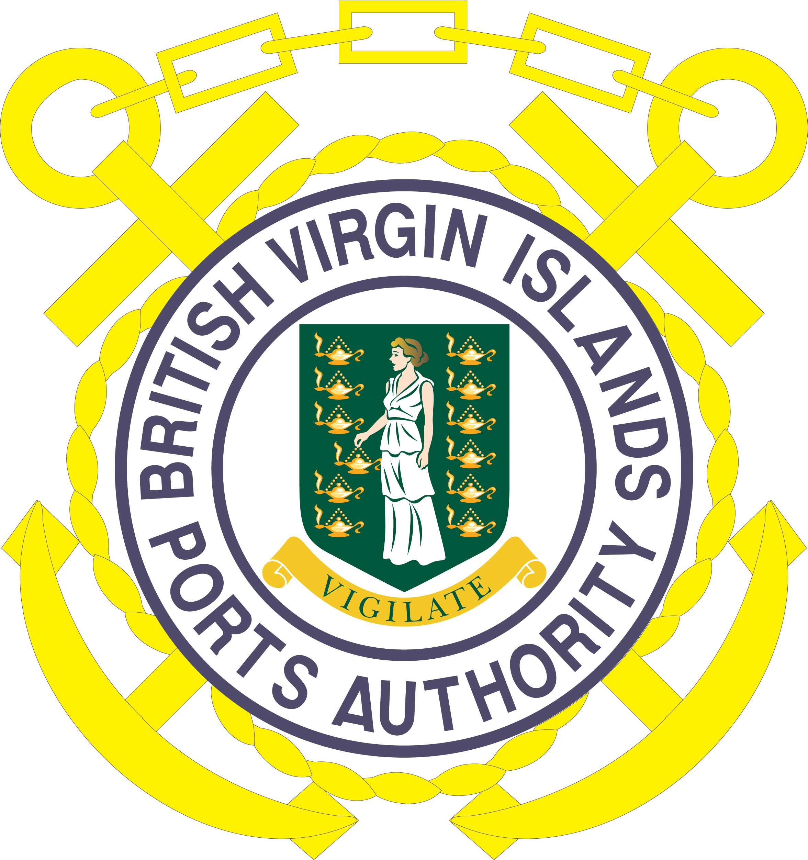
BRITISH VIRGIN ISLANDS PORTS AUTHORITY
VACANCY NOTICE 1/2020

The British Virgin Islands Ports Authority is seeking mature, and highly motivated persons to join our Team in the following position:
Managing Director

Specific Accountabilities:

Plans, develops, controls and supervises the general affairs of the Authority ensuring that:

- All personnel are trained, guided, and developed in the administration and operation of the Ports, including maintenance and effective planning of day-to-day activities to enable them to grow into a team capable of assuming full and continuing responsibility for the efficient operation of the Ports.

- Capabilities of existing staff are continuously assessed and suitable training opportunities are identified for their development including on the-job training as far as possible.

The Managing Director is responsible for the following:

- Evaluates existing Ports and related legislation with a view to refining or improving them by way of amendments from time to time as may be appropriate.

- Ensures that an appropriate system of Management by Objectives is instituted and maintained.

Ensures that an appropriate system designed to provide basic statistical and management information for decision-making is instituted and maintained.

- Ensures that a sound accounting system is instituted and maintained.

- Ensures that viable tariffs are devised and presented to the Authority for initiation through the necessary legislative measures.

- Oversees selection of appropriate equipment for the Ports and ensuring that a sound programme for preventive maintenance of such equipment is introduced and enforced.

- Ensures that suitable navigational aids are provided and maintained.

- Ensures that an adequate number of pilots are trained and licensed.

(I) Ensures that adequate ports safety administration procedures are maintained.

- Ensures that adequate ports security systems are maintained.

- Ensures that adequate systems for receipt, storage and discharge of cargo are implemented at the Ports in an efficient timely and economical manner.

- Ensures that adequate systems for efficient passenger-ferry operations are implemented and maintained at all ferry terminals.

- Ensures that adequate systems for efficient handling of cruise terminal operations are implemented and maintained.

- Cultivates good labour relations and developing employment policies directed towards the development of a permanent, harmonious and productive labour force.

- Establishes and maintains a programme of staff labour training.

- Cultivates and maintains good relations with the main users of the ports through effective communications on all aspects of port procedures and in particular in respect of any changes in procedures being introduced.

(r) Maintains good relations and open communications with the Chairman and Members of the Authority’s Board.

Person Specifications:

Minimum Acceptable Academic/Technical/Professional Qualifications

- First Degree in Management/Port Operations
- Post graduate qualifications in Management, Port Operations/Logistics or Operations Management

Minimum Number of Years of Relevant Experience
• Ten years’ experience in a Senior Management Post, preferably Port Management

Specific Skills/Experience and/or Knowledge
• Experience in negotiation

Salary:

Remuneration/ Benefits: Based on qualifications and experience.

Closing Date: 7th January, 2020.

APPLICATIONS:

All interested applicants must submit a completed Application Form along with the required documents during the hours of 8:30 a.m. - 4:30 p.m. Monday – Friday, to the following physical address. Application forms can be collected at the Main Office or online. Online Applications are also accepted. For more information, please contact:

Chairman of BVIPA Board of Directors
British Virgin Islands Ports Authority
Box 4, Road Town, Tortola.
British Virgin Islands
or email to: jjthomas@bviports.org
For further information, please visit our website at www.bviports.org

