RESTAURANT FOR SALE
OMAR’S CAFE
(Formerly D’ Best Cup)
Soper’s Hole Marina, Westend, Tortola, British Virgin Island
introduction: Well established, independently owned full-service Café, Great turnkey operation with an existing client base that has consistently increased over time. Everything is in place to take over and take what has already been established and make it grow even more. We provide home style cooking specialty coffee drinks, breakfast from 7am until 2pm, hot and cold items sandwiches, homemade waffle, pancake, French toast and many other breakfast treats in a great atmosphere which brings people back time and time again. The restaurant is housed in a two storey building with a storeroom upstairs and downstairs seating for 40, outside seating for 60, and is situated on Soper’s hole busy marina, 3 minutes away from the Westend Ferry dock. Its located along a heavily traveled main road. This café is undoubtedly the best in the Bvi, gaining great business from both locals and tourist alike.
Omar’s Cafe is a successful business that has been operating for over 13 years at Soper’s hole Marine on Frenchman’s Cay on the westend of Tortola.
Products and Services:
- Serves the best brewed coffee on island and Tea along with international and local breakfast (sandwiches, omelets, steak and eggs, sweet delights).
- Kitchen: We have a fully equipped kitchen (hot plates, grill, oven, deep fryer, range, prep fridges blenders, etc).
Location:
- We are situated on Soper’s Hole Marina, Frenchman’s Cay, Westend. We have seating for 40 inside the cafe and an additional 45 outside overlooking the waters on the marina. Soper’s Hole is a busy barina, located just 3 minutes away from the Westend Ferry Dock.
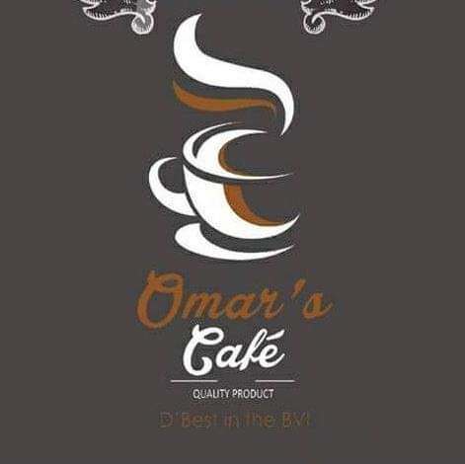
Clientele:
- Our customers are a range of locals, tradesmen, tourists and business workers. We have a large number of repeat customers.
Staff:
- We have 4 fulltime staff and 2 part-time. The owner works fulltime in the cafe.
Opening Hours:
- Monday - Sunday: 7:00am - 2:00pm

Financials:
- Successful business with solid financials. Available upon signed confidentiality agreement.
Reason For Selling:
- Owner is looking into other business venture after successfully running the café for approximately 13 years.

For more information regarding this business and to arrange an inspection, please contact directly on 1-284-344-3357. Only person that has the necessary means of purchasing needs to call.

